МИНИСТЕРСТВО НАУКИ И ВЫСШЕГО ОБРАЗОВАНИЯ  
РОССИЙСКОЙ ФЕДЕРАЦИИ

федеральное государственное автономное   
образовательное учреждение высшего образования  
«Самарский национальный исследовательский университет   
имени академика С.П. Королева»

(Самарский университет)

Институт информатики, математики и электроники

Факультет информатики  
Кафедра суперкомпьютеров и общей информатики

**Отчет по лабораторным работам №№ 1, 3**

Дисциплина: «Enterprise Systems Development (Методы проектирования и поддержки требований к программному обеспечению)»

Тип предприятия: **«Pool chain»**

Выполнил: Сахипов А. Г.

Группа: 6234-010402D

Самара 2021

**Assignment #1. Use Case diagram**

**Task 1**

The chosen company type is Music store chain.

**Task 2**

1. Musical instrument store allows you to view the catalog of instruments;
2. Musical instrument store allows see the characteristics of the product;
3. Musical instruments website allows you to add several products to your shopping cart;
4. Musical instruments website allows you to remove unwanted items from the shopping cart;
5. The musical instrument store allows you to compare the characteristics of the products

**Task 3**

Glossary:

Customer – user of the system, who is interested music instruments and buy music instruments online (using website)

Music instrument shop – system, which allows customers choose and buy music instruments online (using website).

Company owner – person, who is interested in increasing of the income by the music instruments shop.

Administrator – person, who manages the program part of music instruments shop and may change information in the website.

Music instrument – fragment, that displays a real musical instrument.

Price - characteristic of a product, that indicates its value.

Year - year the musical instrument was created.

Country - country where the musical instrument was created.

Category - indicates which type a musical instrument belongs to.

**Task 4**

The Use Case diagram is illustrated in Figure 1.

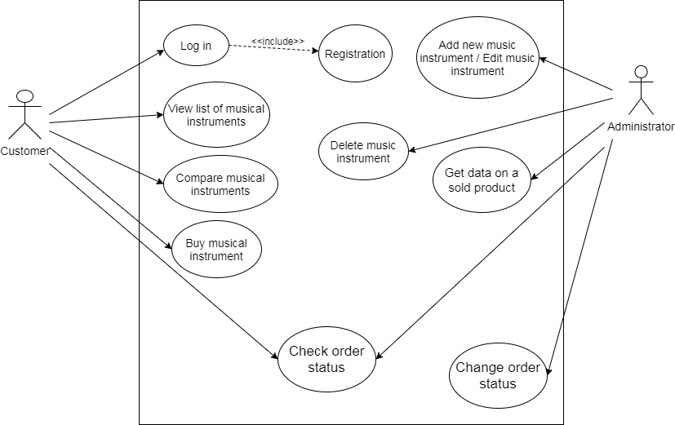

Figure 1 – Music store chain. Use Case diagram

**Task 5**

*Use Case 1*

**Use Case:** Registration

**Actors:** Customer

**Goal:** Create account

**Short description:** Customer fills out the registration form to create an account in the system

**Scenario:**

1. Customer goes on the website of music instrument shop
2. Customer click button “Registration”
3. Customer fills out form

Input form:

First name: ______

Last name: ______

Email: __________

Password: _______

1. Customer click button “Create account”

**Exception 1: This customer already exists.**

1. Send email for confirm registration
2. Customer goes on his email
3. Customer confirm registration

*Use Case 2*

**Use Case:** Log in

**Actors:** Customer

**Goal:** Login to account

**Short description:** Customer fills out the login form to sign in an account

**Scenario:**

1. Customer goes on the website of music instrument shop
2. Customer fills out form

Input form:

Email: _______

Password: ____

1. Customer click button “Log in”

**Exception 1: Login or password is incorrect**

1. Customer is redirect to main page

*Use Case 3*

**Use Case:** View list of musical instruments

**Actors:** Customer

**Goal:** View Products Available

**Short description:** Customer views list of musical instruments

**Scenario:**

1. Customer goes on the website of music instrument shop
2. Customer views list of musical instruments

View: Products are listed one after another

Characteristics: product features shown in the product list. (name, price, year of manufacture, country, category, images, reviews, rating)

Filters: Customer can filter product by name, price, year, country, category by decreasing or increase

Search: Customer can search product by name, price, year, country, category

*Use Case 4*

**Use Case:** Compare musical instruments

**Actors:** Customer

**Goal:** Compare products

**Short description:** Compare the characteristics of several musical instruments

**Scenario:**

1. Customer goes on the website of music instrument shop
2. Customer clicks button “add to comparison” on multiple products
3. Customer clicks button “Compare products”
4. Customer redirected to product comparison page

View:

|  |  |  |
| --- | --- | --- |
|  | Guitar_1 | Guitar_2 |
| price | 1999 | 1950 |
| year of manufacture | 2005 | 2003 |
| country | USA | Canada |
| rating | 5.0 | 4.4 |

*Use Case 5*

**Use Case:** Buy musical instrument

**Actors:** Customer

**Goal:** Purchase product

**Short description:** Purchase selected product

**Scenario:**

1. Customer goes on the website of music instrument shop
2. Customer log in

**Exception 1: Login or password is incorrect**

1. Customer selected product
2. Customer click “buy product”
3. Product add to shopping cart
4. Customer can continues add product in shopping cart(point 3-4) or go to payment page
5. Customer fills out form with type pay, delivery and address

Input form:

Pay(dropdawn): bank card or cash

Delivery(dropdawn): pickup or courier delivery

Address(text): customer address

1. Create a unique order number
2. The calculation of the cost of delivery

**Exception 2: Fill all necessary fields**

1. Customer redirected to page with information about order
2. Send email to customer

|  |  |  |  |  |
| --- | --- | --- | --- | --- |
| Order date | Order number | Customer name | Delivery status | Payment status |
| 18.03.2020 | 3 | First_name Last_name | In stock | Cash(Waiting) |

|  |  |  |
| --- | --- | --- |
| Product name | Quantity | Sum, rub |
| Piano | 3 | 3000,00 |
| Guitar | 1 | 1000,00 |
|  |  |  |
| Total | 4 | 4000,00 |

*Use Case 6*

**Use Case:** Edit music instrument / Add new music instrument

**Actors:** Administrator

**Goal:** Edit music instrument / Add new product

**Short description:** Change the output characteristics of a musical instrument / Add new product for customers

**Scenario:**

1. Administrator goes on the website of music instrument shop
2. Administrator log in

**Exception 1: Login or password is incorrect**

1. Administrator selects the desired product
2. Administrator click button “Edit” / Administrator click button “Add new product”
3. Redirect to the page with the product information form
4. Administrator adds the necessary fields

Input form:

Product name: _________

Price: ________________

Quantity: _____________

Year: ________________

Country: _____________

Category: ____________

1. Administrator click button “Save”

**Exception 2: Fill all necessary fields**

1. Modified or new musical instrument appears on the list

*Use Case 7*

**Use Case:** Delete music instrument

**Actors:** Administrator

**Goal:** Delete music instrument

**Short description:** Delete unnecessary product

**Scenario:**

1. Administrator goes on the website of music instrument shop
2. Administrator log in

**Exception 1: Login or password is incorrect**

1. Administrator selects the desired product
2. Administrator click button “Delete”
3. Dialog box appears confirming the removal of the product.
4. Administrator click button “Yes”

*Use Case 8*

**Use Case:** Get data on a sold products

**Actors:** Administrator

**Goal:** Get data on a sold products

**Short description:** View list of sold products

**Scenario:**

1. Administrator goes on the website of music instrument shop
2. Administrator log in

**Exception 1: Login or password is incorrect**

1. Administrator click button “Sold products”
2. Redirect to page with list of sold products

|  |  |  |  |
| --- | --- | --- | --- |
| Date | Product name | Quantity | Sum, rub |
| 18.03.2020 | Piano | 3 | 3000,00 |
|  |  |  |  |
| Total |  |  | 3000,00 |

*Use Case 9*

**Use Case:** Check order status

**Actors:** Administrator / Customer

**Goal:** Get data about status order

**Short description:** View status order

**Scenario:**

1. Administrator / Customer goes on the website of music instrument shop
2. Administrator / Customer log in

**Exception 1: Login or password is incorrect**

1. Administrator / Customer click button “Status orders”
2. Administrator / Customer is redirect to page list status orders

Order status type: In stock, Courier took the order, Delivered

Payment status type: Bank card(waiting), Cash(waiting), Paid

|  |  |  |  |  |  |  |  |
| --- | --- | --- | --- | --- | --- | --- | --- |
| Date order | Order numder | Customer name(for only admin) | Product name | Quantity | Sum, rub | Status | Payment |
| 18.03.2020 | 3 | First_name Last_name | Piano | 3 | 3000,00 | In stock | Paid |
| 18.03.2020 | 3 | First_name Last_name | Guitar | 1 | 1000,00 | In stock | Paid |
| 18.03.2020 | 5 | First_name  Last_name | Guitar | 1 | 1000,00 | Delivered | Cash  (waiting) |

Filter: Administrator can filter data by date order, customer name, product name, status. Customer can filter data date order, product name, status.

Search: Administrator can search data by date order, customer name, product name, status, order number. Customer can search data date order, product name, status, order number.

*Use Case 10*

**Use Case:** Change order status

**Actors:** Administrator

**Goal:** Change status order

**Short description:** Change status order

**Scenario:**

1. Administrator goes on the website of music instrument shop
2. Administrator log in

**Exception 1: Login or password is incorrect**

1. Administrator selects the desired order
2. Administrator click button “Edit status orders”
3. Administrator is redirect to page status order
4. Administrator changes the status order (“In stock” or “Courier took the order” or “Delivered”)

**Assignment #3. Class diagram**

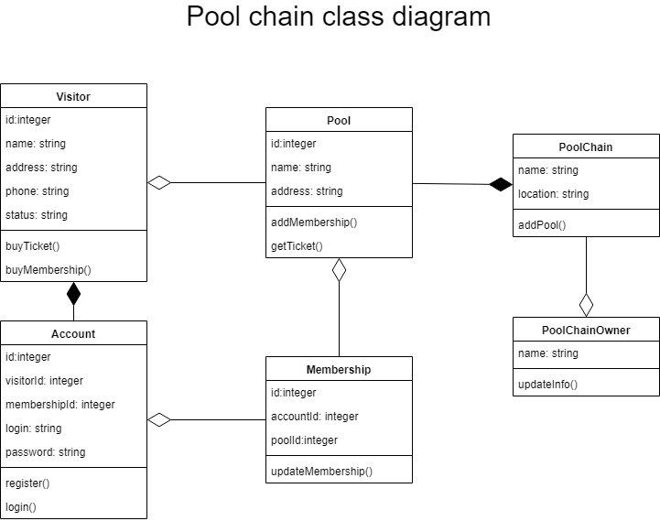

Figure 2 – Pool chain. Class diagram